LAPORAN ANALISI SOAL
DI BUTUHKAN UNTUK MEMENUHI KEBUTUHAN TUGAS MATA KULIAH SYSTEM OPERASI
MODUL 4
DOSEN : TRIAWAN ADI CAHYANTO M.KOM


OLEH
NAMA: MUHAMMAD NOVAL RAMADHAN
NIM:2410651061

UNIVERSITAS MUHAMMADIYAH JEMBER
10/16/2025

TUGAS
- A
Output FCFS : average time 7.33
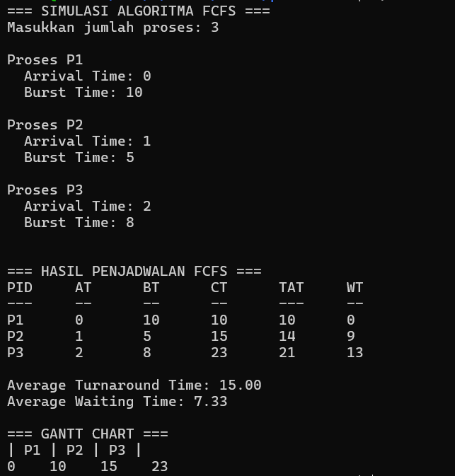
Output ROUND_ROBIN : avg tm 23944624.00

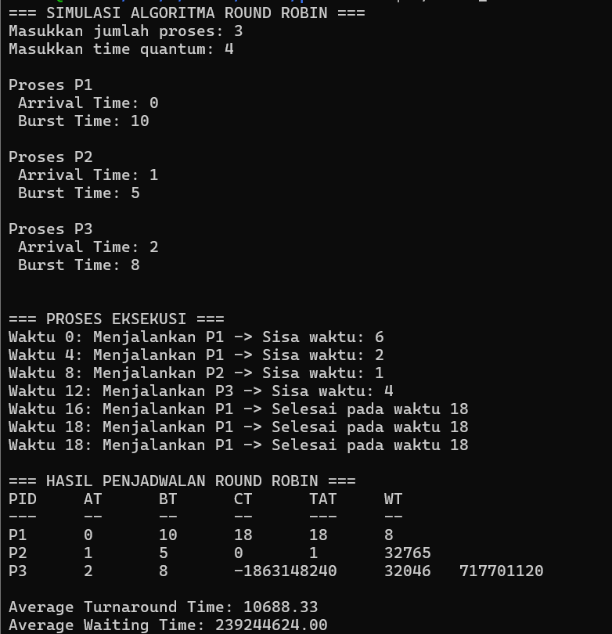

Output SJF : avg tm same with fcfs, is 7.33
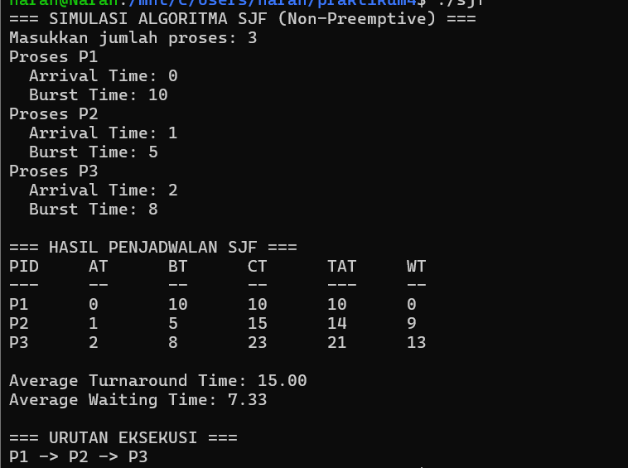

B
Output FCFS : avg tm 5.75
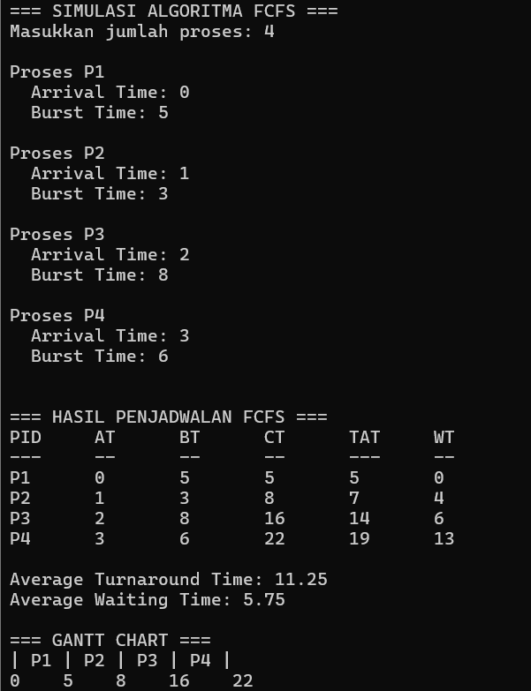

Output ROUND_ROBIN : avg tm is 8197.75
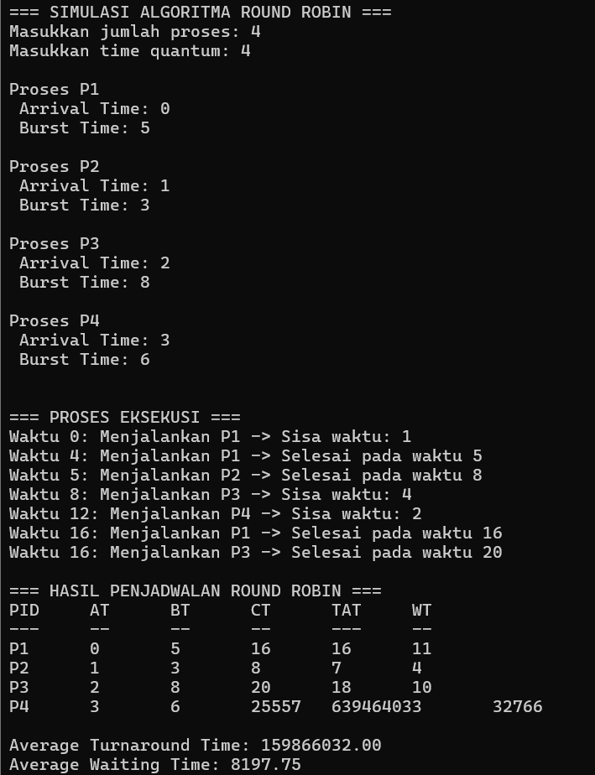

Output SJF : avg tm 5.25
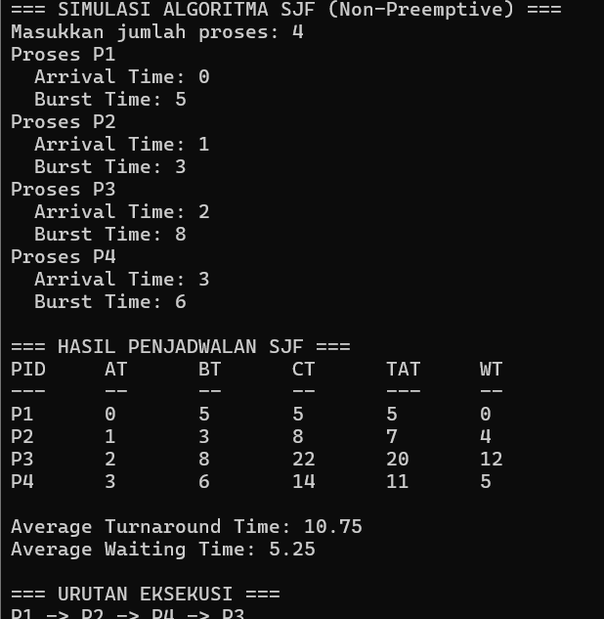
Jawaaa Ban Analysis Experiment Ke Tiga Algoritma
- avg terkecil data pertama Adalah FCFS dan SJF, dan avg terkecil data ke dua Adalah algoritma SJF
- mengapa hasil algoritma berbeda? Ya karna cara kerja algoritma tersebut berbeda beda
- kapaan menggunakan FCFS ? kesederhanaan dan kemudahan implementasi,proses yang ditangani umumnya memiliki burst time yng pendek
- kapan menggunakan FJS ? Tujuan utamanya adalah meminimalkan waktu tunggu rata-rata dan waktu penyelesaian rata-rata, Waktu eksekusi proses dapat diestimasi atau diketahui sebelumnya, yang merupakan prasyarat utama algoritma ini.
- Kapan menggunakan Round_robin ? Prioritasnya adalah memberikan waktu respons yang cepat dan adil, Beban kerja tidak dapat diprediksi, dan tidak ada informasi mengenai waktu eksekusi proses sebelumnya.

Tugas 3 modifikasi program
The code:
#include <stdio.h>
struct Process {
int pid;
int arrival_time;
int burst_time;
int start_time;
int completion_time;
int turnaround_time;
int waiting_time;
};
int main() {
int n;
FILE *input = fopen("input.txt", "r");
if (input == NULL) {
printf("Gagal membuka file input.txt. Pastikan file ada di folder yang sama.\n");
return 1;
}
fscanf(input, "%d", &n);
struct Process proc[n];
for (int i = 0; i < n; i++) {
proc[i].pid = i + 1;
fscanf(input, "%d %d", &proc[i].arrival_time, &proc[i].burst_time);
}
fclose(input);
int current_time = 0;
for (int i = 0; i < n; i++) {
if (current_time < proc[i].arrival_time)
current_time = proc[i].arrival_time;
proc[i].start_time = current_time;
proc[i].completion_time = current_time + proc[i].burst_time;
proc[i].turnaround_time = proc[i].completion_time - proc[i].arrival_time;
proc[i].waiting_time = proc[i].turnaround_time - proc[i].burst_time;
current_time = proc[i].completion_time;
}
float total_tat = 0, total_wt = 0;
FILE *output = fopen("hasil_fcfs.txt", "w");
if (output == NULL) {
printf("Gagal membuka file hasil_fcfs.txt untuk menyimpan hasil.\n");
return 1;
}
printf("\n=== HASIL PENJADWALAN FCFS ===\n");
printf("PID\tAT\tBT\tST\tCT\tTAT\tWT\n");
printf("---\t--\t--\t--\t--\t---\t--\n");
fprintf(output, "=== HASIL PENJADWALAN FCFS ===\n");
fprintf(output, "PID\tAT\tBT\tST\tCT\tTAT\tWT\n");
fprintf(output, "---\t--\t--\t--\t--\t---\t--\n");
for (int i = 0; i < n; i++) {
printf("P%d\t%d\t%d\t%d\t%d\t%d\t%d\n",
proc[i].pid, proc[i].arrival_time, proc[i].burst_time,
proc[i].start_time, proc[i].completion_time,
proc[i].turnaround_time, proc[i].waiting_time);
fprintf(output, "P%d\t%d\t%d\t%d\t%d\t%d\t%d\n",
proc[i].pid, proc[i].arrival_time, proc[i].burst_time,
proc[i].start_time, proc[i].completion_time,
proc[i].turnaround_time, proc[i].waiting_time);
total_tat += proc[i].turnaround_time;
total_wt += proc[i].waiting_time;
}
float avg_tat = total_tat / n;
float avg_wt = total_wt / n;
printf("\nAverage Turnaround Time: %.2f\n", avg_tat);
printf("Average Waiting Time: %.2f\n", avg_wt);
fprintf(output, "\nAverage Turnaround Time: %.2f\n", avg_tat);
fprintf(output, "Average Waiting Time: %.2f\n", avg_wt);

printf("\n=== GANTT CHART (Detail) ===\n|");
fprintf(output, "\n=== GANTT CHART (Detail) ===\n|");
for (int i = 0; i < n; i++) {
printf(" P%d |", proc[i].pid);
fprintf(output, " P%d |", proc[i].pid);
}
printf("\n");
fprintf(output, "\n");
printf("%d", proc[0].start_time);
fprintf(output, "%d", proc[0].start_time);
for (int i = 0; i < n; i++) {
printf("\t%d", proc[i].completion_time);
fprintf(output, "\t%d", proc[i].completion_time);
}
printf("\n\nKeterangan:\n");
fprintf(output, "\n\nKeterangan:\n");
for (int i = 0; i < n; i++) {
printf("P%d: Start = %d, Finish = %d\n", proc[i].pid, proc[i].start_time, proc[i].completion_time);
fprintf(output, "P%d: Start = %d, Finish = %d\n", proc[i].pid, proc[i].start_time, proc[i].completion_time);
}
fclose(output);
printf("\nHasil disimpan ke file hasil_fcfs.txt\n");
return 0;
}

The output :
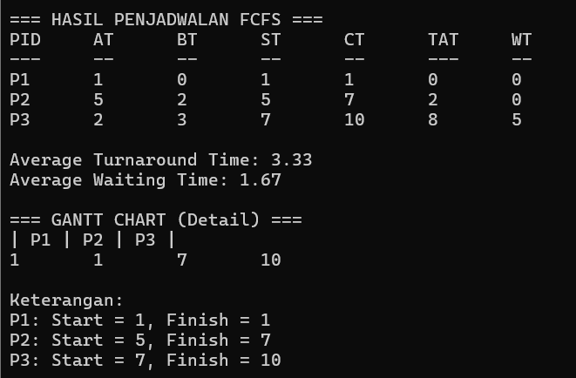

- ROUND_ROBIN
Modified code:
// round_robin.c
#include <stdio.h>
#include <stdbool.h>

struct Process {
int pid;
int arrival_time;
int burst_time;
int remaining_time;
int completion_time;
int turnaround_time;
int waiting_time;
};

int main() {
FILE *input = fopen("input1.txt", "r"); // <- baca input1.txt
if (!input) {
printf("Gagal membuka file input1.txt. Pastikan file ada di folder yang sama.\n");
return 1;
}

int n, quantum;
fscanf(input, "%d", &n);
struct Process proc[n];
for (int i = 0; i < n; i++) {
fscanf(input, "%d %d %d", &proc[i].pid, &proc[i].arrival_time, &proc[i].burst_time);
proc[i].remaining_time = proc[i].burst_time;
proc[i].completion_time = 0;
proc[i].turnaround_time = 0;
proc[i].waiting_time = 0;
}
fscanf(input, "%d", &quantum);
fclose(input);

int current_time = 0;
int completed = 0;
int queue[1000];
int front = 0, rear = 0;
bool in_queue[n];
for (int i = 0; i < n; i++) in_queue[i] = false;

// Gantt storage
int gantt_pid[5000];
int gantt_start[5000];
int gantt_end[5000];
int gantt_count = 0;

// masukkan proses yang sudah datang pada time 0
for (int i = 0; i < n; i++) {
if (proc[i].arrival_time <= current_time && proc[i].remaining_time > 0 && !in_queue[i]) {
queue[rear++] = i;
in_queue[i] = true;
}
}

while (completed < n) {
if (front == rear) { // queue kosong -> maju waktu sampai ada proses datang
current_time++;
for (int i = 0; i < n; i++) {
if (proc[i].arrival_time <= current_time && proc[i].remaining_time > 0 && !in_queue[i]) {
queue[rear++] = i;
in_queue[i] = true;
}
}
continue;
}

int idx = queue[front++]; // ambil index proses
in_queue[idx] = false;

// catat start
gantt_pid[gantt_count] = proc[idx].pid;
gantt_start[gantt_count] = current_time;

if (proc[idx].remaining_time > quantum) {
current_time += quantum;
proc[idx].remaining_time -= quantum;
gantt_end[gantt_count] = current_time;
gantt_count++;
} else {
// selesai
current_time += proc[idx].remaining_time;
proc[idx].remaining_time = 0;
proc[idx].completion_time = current_time;
proc[idx].turnaround_time = proc[idx].completion_time - proc[idx].arrival_time;
proc[idx].waiting_time = proc[idx].turnaround_time - proc[idx].burst_time;
completed++;
gantt_end[gantt_count] = current_time;
gantt_count++;
}

// masukkan proses yang sudah datang sampai current_time
for (int i = 0; i < n; i++) {
if (proc[i].arrival_time <= current_time && proc[i].remaining_time > 0 && !in_queue[i]) {
queue[rear++] = i;
in_queue[i] = true;
}
}

// jika proses belum selesai, masukkan kembali ke queue
if (proc[idx].remaining_time > 0) {
queue[rear++] = idx;
in_queue[idx] = true;
}
}

// Cetak tabel hasil & simpan
FILE *output = fopen("hasil_roundrobin.txt", "w");
if (!output) {
printf("Gagal membuka file hasil_roundrobin.txt untuk menulis.\n");
return 1;
}

printf("\n=== HASIL PENJADWALAN ROUND ROBIN ===\n");
printf("PID\tAT\tBT\tCT\tTAT\tWT\n");
printf("---\t--\t--\t--\t---\t--\n");
fprintf(output, "=== HASIL PENJADWALAN ROUND ROBIN ===\n");
fprintf(output, "PID\tAT\tBT\tCT\tTAT\tWT\n");
fprintf(output, "---\t--\t--\t--\t---\t--\n");

float total_tat = 0, total_wt = 0;
for (int i = 0; i < n; i++) {
printf("P%d\t%d\t%d\t%d\t%d\t%d\n",
proc[i].pid, proc[i].arrival_time, proc[i].burst_time,
proc[i].completion_time, proc[i].turnaround_time, proc[i].waiting_time);
fprintf(output, "P%d\t%d\t%d\t%d\t%d\t%d\n",
proc[i].pid, proc[i].arrival_time, proc[i].burst_time,
proc[i].completion_time, proc[i].turnaround_time, proc[i].waiting_time);
total_tat += proc[i].turnaround_time;
total_wt += proc[i].waiting_time;
}
printf("\nAverage Turnaround Time: %.2f\n", total_tat / n);
printf("Average Waiting Time: %.2f\n", total_wt / n);
fprintf(output, "\nAverage Turnaround Time: %.2f\n", total_tat / n);
fprintf(output, "Average Waiting Time: %.2f\n", total_wt / n);

// Gantt Chart detail
printf("\n=== GANTT CHART (Detail) ===\n|");
for (int i = 0; i < gantt_count; i++) {
printf(" P%d |", gantt_pid[i]);
}
printf("\n");

// print timeline: start times, then final end
for (int i = 0; i < gantt_count; i++) {
if (i == 0) printf("%d", gantt_start[i]);
printf(" %d", gantt_end[i]);
}
printf("\n");

fprintf(output, "\n=== GANTT CHART (Detail) ===\n|");
for (int i = 0; i < gantt_count; i++) fprintf(output, " P%d |", gantt_pid[i]);
fprintf(output, "\n");
for (int i = 0; i < gantt_count; i++) {
if (i == 0) fprintf(output, "%d", gantt_start[i]);
fprintf(output, " %d", gantt_end[i]);
}
fprintf(output, "\n");

fclose(output);
printf("\nHasil juga disimpan ke file: hasil_roundrobin.txt\n");
return 0;
}

The output:
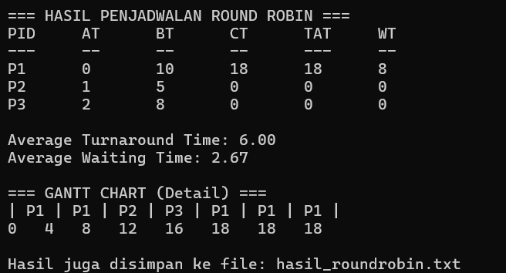

SJF modified
Modifed code:
// sjf.c (non-preemptive, baca input2.txt)
#include <stdio.h>
#include <stdbool.h>

struct Process {
int pid;
int arrival_time;
int burst_time;
int completion_time;
int turnaround_time;
int waiting_time;
bool is_completed;
};

int main() {
FILE *input = fopen("input2.txt", "r"); // <- baca input2.txt
if (!input) {
printf("Gagal membuka file input2.txt. Pastikan file ada di folder yang sama.\n");
return 1;
}

int n;
fscanf(input, "%d", &n);
struct Process proc[n];
for (int i = 0; i < n; i++) {
fscanf(input, "%d %d %d", &proc[i].pid, &proc[i].arrival_time, &proc[i].burst_time);
proc[i].is_completed = false;
proc[i].completion_time = 0;
proc[i].turnaround_time = 0;
proc[i].waiting_time = 0;
}
fclose(input);

int current_time = 0;
int completed = 0;
int sequence[1000];
int seq_count = 0;

while (completed < n) {
int shortest = -1;
int min_burst = 1e9;
for (int i = 0; i < n; i++) {
if (!proc[i].is_completed && proc[i].arrival_time <= current_time) {
if (proc[i].burst_time < min_burst) {
min_burst = proc[i].burst_time;
shortest = i;
}
}
}
if (shortest == -1) {
current_time++;
continue;
}

// jalankan proses shortest (non-preemptive)
sequence[seq_count++] = shortest;
current_time += proc[shortest].burst_time;
proc[shortest].completion_time = current_time;
proc[shortest].turnaround_time = proc[shortest].completion_time - proc[shortest].arrival_time;
proc[shortest].waiting_time = proc[shortest].turnaround_time - proc[shortest].burst_time;
proc[shortest].is_completed = true;
completed++;
}

// simpan hasil
FILE *output = fopen("hasil_sjf.txt", "w");
if (!output) {
printf("Gagal membuka file hasil_sjf.txt untuk menulis.\n");
return 1;
}

printf("\n=== HASIL PENJADWALAN SJF ===\n");
printf("PID\tAT\tBT\tCT\tTAT\tWT\n");
printf("---\t--\t--\t--\t---\t--\n");
fprintf(output, "=== HASIL PENJADWALAN SJF ===\n");
fprintf(output, "PID\tAT\tBT\tCT\tTAT\tWT\n");
fprintf(output, "---\t--\t--\t--\t---\t--\n");

float total_tat = 0, total_wt = 0;
for (int i = 0; i < n; i++) {
printf("P%d\t%d\t%d\t%d\t%d\t%d\n",
proc[i].pid, proc[i].arrival_time, proc[i].burst_time,
proc[i].completion_time, proc[i].turnaround_time, proc[i].waiting_time);
fprintf(output, "P%d\t%d\t%d\t%d\t%d\t%d\n",
proc[i].pid, proc[i].arrival_time, proc[i].burst_time,
proc[i].completion_time, proc[i].turnaround_time, proc[i].waiting_time);
total_tat += proc[i].turnaround_time;
total_wt += proc[i].waiting_time;
}

printf("\nAverage Turnaround Time: %.2f\n", total_tat / n);
printf("Average Waiting Time: %.2f\n", total_wt / n);
fprintf(output, "\nAverage Turnaround Time: %.2f\n", total_tat / n);
fprintf(output, "Average Waiting Time: %.2f\n", total_wt / n);

// Gantt Chart (non-preemptive: per job)
printf("\n=== GANTT CHART ===\n|");
for (int i = 0; i < seq_count; i++) {
printf(" P%d |", proc[sequence[i]].pid);
}
printf("\n0");
for (int i = 0; i < seq_count; i++) {
printf(" %d", proc[sequence[i]].completion_time);
}
printf("\n");

fprintf(output, "\n=== GANTT CHART ===\n|");
for (int i = 0; i < seq_count; i++) fprintf(output, " P%d |", proc[sequence[i]].pid);
fprintf(output, "\n0");
for (int i = 0; i < seq_count; i++) fprintf(output, " %d", proc[sequence[i]].completion_time);
fprintf(output, "\n");

fclose(output);
printf("\nHasil juga disimpan ke file: hasil_sjf.txt\n");
return 0;
}

The output:
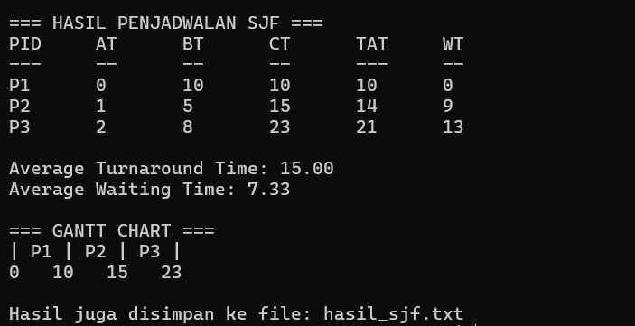

Data satu dengan burst time berfariasi
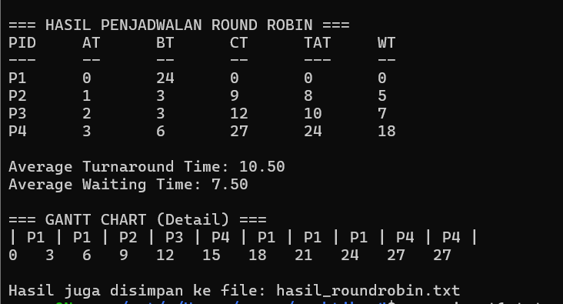

Data dua dengan datang bersamaan
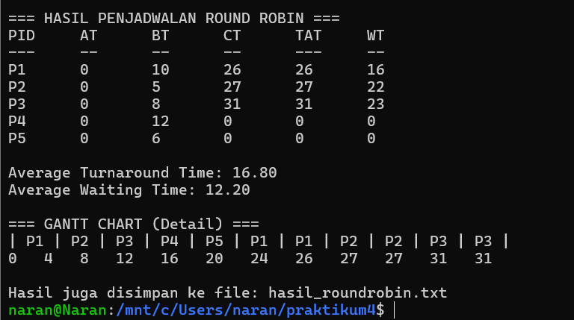

Data tiga dengan interfal
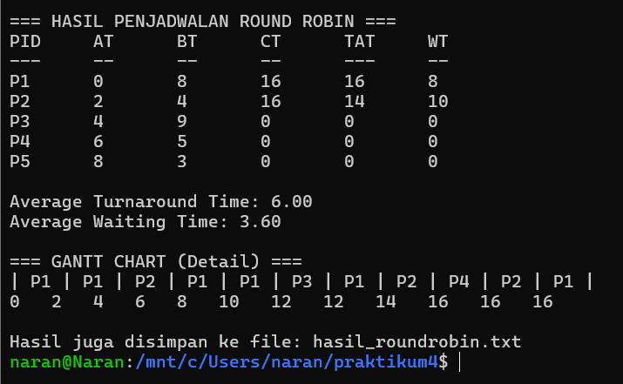
TUGAS 5.
SOAL
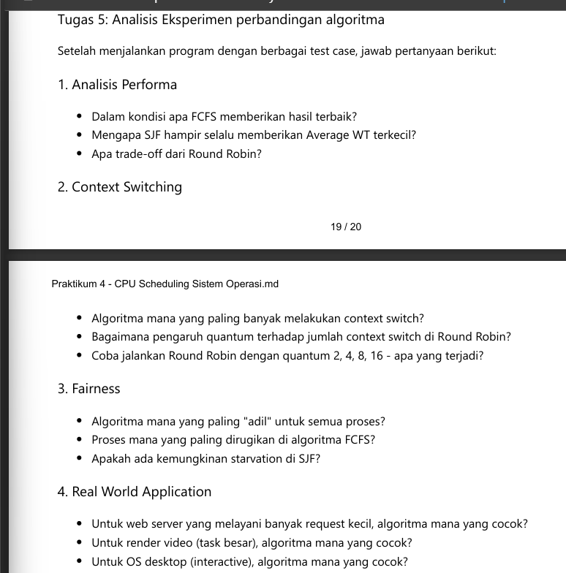

Jawaban
  - yaitu saa burstime si data pendek
  - Karna si SJF selalu mengeksekusi burstime yang terpendek terlebih dahulu baru mengeksekusi yang Panjang
  - Trade-off robin yaitu tingginya overheat karna terlalu banyak switc penyebabnya yaitu quantu time nya terlalu pndek sih biasanya

  - Round robin Adalah yang paling banyak melakuka cortex switc
  - Semakin kecil quatum semakin banyak switc nya sebaliknya jika quantumnya semakin besar atau pendek.
  - Jika km menjalankan algoritma round robin dengan quantum 1-2 switching nya itu cepat terus system jadi lambat karna overhead, terus klk quantumnya km kasih 10-berapa gitu, nanti jadinya kelambaten terus malah lebih mirip fcfs,respon ke proseslain menurun, tapi klk quantum 2-6 itu malah bagus karna itu standar ga terlalu lambat dan gak terlalu cepet cmiw.

3.1. Algoritma yang paling adil (fair) adalah Round Robin (RR).
3.2. Proses yang paling dirugikan di FCFS adalah proses dengan burst time yang pendek.
3.3. Ya, ada kemungkinan starvation di algoritma SJF (non-preemptive) atau Shortest Remaining Time First (SRTF, yang merupakan SJF preemptive).

4.1 Round Robin (RR) atau varian Priority Scheduling (dengan preemption) sangat cocok.
4.2. FCFS (First-Come, First-Served) atau SJF (non-preemptive) cocok.
4.3. Round Robin (RR) yang dikombinasikan dengan Multilevel Feedback Queue (MLFQ).

